**Name: KAMCHE YANN ARNAUD**

**Matricule : FE21A208**

**Department: Computer Engineering**

**Level: 300**

**Task: Implement a stack using array**

1. **CODE**

/*STACK IMPLEMENTATION

Using Arrays

10/20/2022

*/

#include<stdio.h>

#include<conio.h>

#include<stdlib.h>

#define MAX_SIZE 100

int A[MAX_SIZE];

int top = -1; // Top iterates through the overall array

int result;

//Create function

void Create(int Size_List)

{

int A[Size_List];

return;

}

/*Push function: Inserts an element into the stack

If the stack is full(Overflow), 'Push' will not succeed

*/

void Push(int max_size, int element)

{

if( top == max_size - 1)

{

printf("Error: STACK OVERFLOW");

return;

}

A[++top] = element; //We use pre-increment operator. Incrementation will take place first.

}

/*Pop functions removes an element from the array

If the array is empty, an error is displayed

*/

int Pop()

{

int pop;

pop = top;

if( top == -1)

return 0;

else

--top;

return A[pop];

}

//sizeOfStack function returns the size of the task

int sizeOfStack()

{

int size;

size = top;

return ++size;

}

/*TOP fuction returns data at top index*/

int TopOfStack()

{ if(top == -1)

return 0;

else

return A[top];

}

/*Display fuction dispalys the content of the stack*/

void Display()

{

int i;

if (top == -1)

printf("Stack is Empty");

else

{

printf("Stack: ");

for(i = 0; i<= top; i++)

printf("%d ", A[i]);

printf("\n");

}

}

//

void Status_Stack(int size)

{

if(top== -1)

{

printf("STATUS: Empty\n");

return;

}

else if (top == size - 1)

{

printf("STATUS: FULL\n");

return;

}

else

{

printf("STATUS: Not Empty\n");

return;

}

}

int main()

{

system("color 2");

int choice, num, Size_List;

printf("Enter the size of your List: ");

scanf("%d", &Size_List);

Create(Size_List);

printf("1. Push\n");

printf("2. Pop\n ");

printf("3. Display Element at the Top of your list\n");

printf("4. Display your list\n");

printf("5. Status of stack\n");

printf("6. Size of stack\n");

options:

printf("\nChoose the operation to be performed with your list: ");

scanf("%d", &choice);

while(choice == 1|| choice == 2|| choice == 3|| choice == 4 || choice == 5 || choice == 6)

{

while(choice==1)

{

printf("Enter a number: ");

scanf("%d", &num);

Push(Size_List, num);

goto options;

}

while(choice == 2)

{

result = Pop();

if (result == 0)

printf("Empty");

else

printf("%d", result);

goto options;

}

while(choice == 3)

{

result = TopOfStack();

if (result == 0)

printf("Empty");

else

printf("%d", TopOfStack());

goto options;

}

while(choice == 4)

{

Display(Size_List);

goto options;

}

while(choice == 5){

Status_Stack(Size_List);

goto options;

}

while(choice == 6){

result = sizeOfStack();

if (result == 0)

printf("Empty");

else

printf("%d", sizeOfStack());

goto options;

}

}

return 0;

}

1. **COMPILATION RESULTS**
2. **PUSH OPERATION**

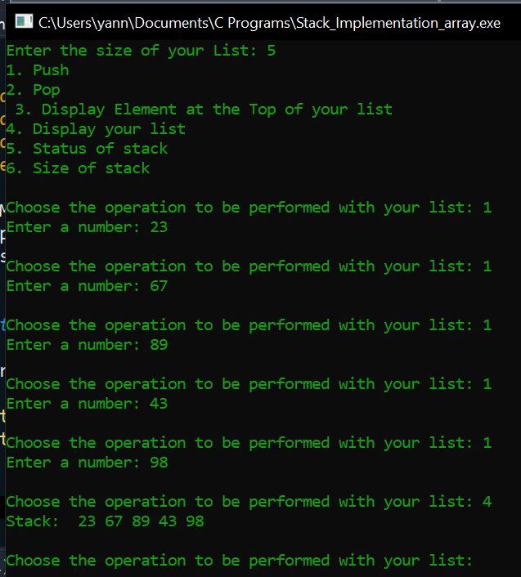

1. **POP OPERATION**

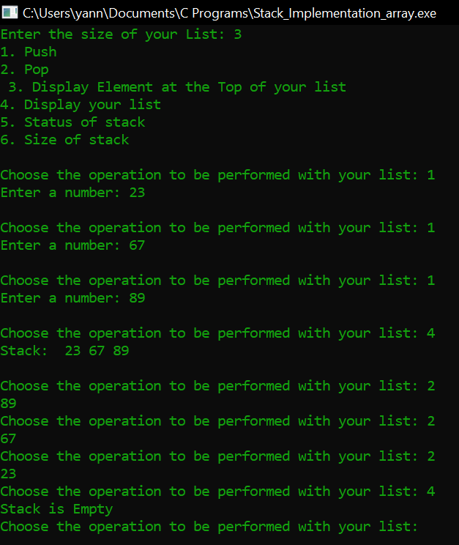

1. **Size of stack**

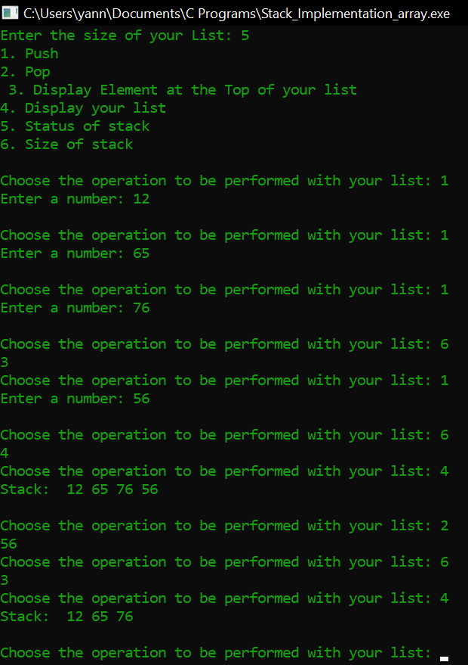

1. **Top of stack**

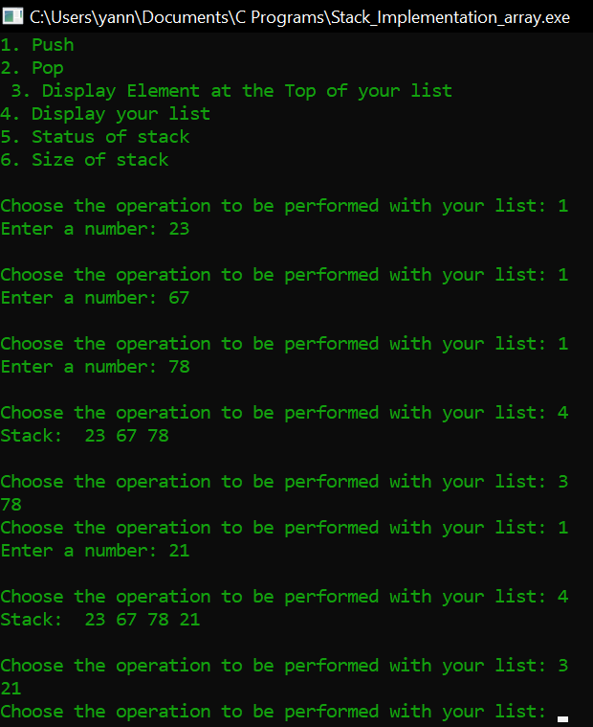

1. **Display stack**

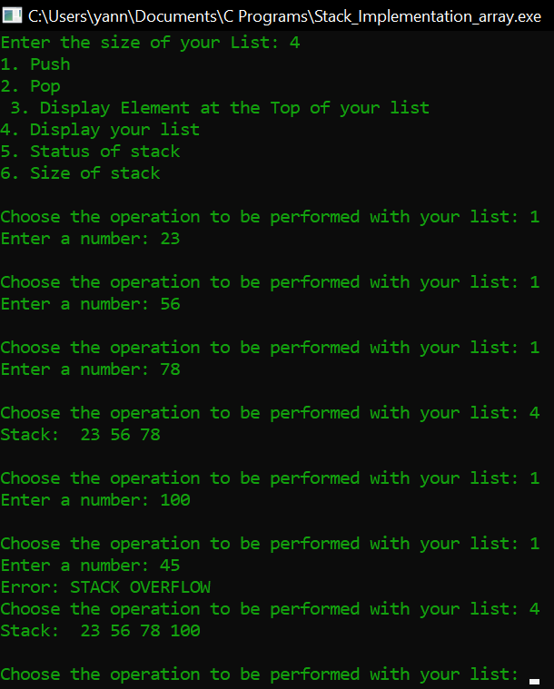

1. **Status of stack**

